Lab11：Memory Hierarchies
提交学号_姓名.doc，practice 1 包括smooth和rotate函数，及运行截图；practice2提交 Memory Mountain图及对问题的回答（请按题目顺序编号，可以参考书中对应章节或课件回答问题）

Practice 1: Locality Optimizing

INTRODUCTION
This exercise deals with optimizing memory-intensive code. Image processing is one area that benefits greatly from such optimizations.
In this exercise we'll be optimizing two functions: rotate, a function designed to rotate an image 90 degrees clockwise, and smooth, a function designed to smooth (or more precisely to blur) an image. Your goal is to maximize the cache hit rate of these functions on a simulated L1 cache. We provide you with a cache simulator that simulates the performance of a computer's cache.
For our purposes, we will consider an image to be represented by a two-dimensional matrix M, where M_{i,j} denotes the (i,j)th pixel of M. To simplify things, this assignment will deal only with square images. Rows and columns are numbered in zero-indexed fashion (like arrays), so rows and columns number from 0 to N-1, where N is the width/height of the image matrix. Pixel values consist of four 1-byte fields representing red, green, blue, and alpha.

LOGISTICS
The files needed for this assignment can be downloaded here. Once you've extracted the zip file to its own directory, you'll see a number of C source and header files:
 | File: | Function:
 | cache.c | Contains the code used for the cache simulation
 | cache.h | Header file for cache simulator
 | defs.h | Contains commonly used definitions and structures
 | exercise5.dsp | Exercise 5 project file
 | exercise5.dsw | Exercise 5 workspace file
 | driver.c | The main program for testing various functions
 | rotate.c | Contains the rotate functions. You will modify this file.
 | smooth.c | Contains the smooth functions. You will modify this file.
The only files you need to change, and the only files you will submit, are rotate.c and smooth.c. You're free to change the driver program as you see fit, but such changes won't be submissible.

IMPLEMENTATION DETAILS

Data Representation:
The fundamental data structure of our images is the pixel structure, shown below:
typedef struct {
unsigned short red : 8;
unsigned short green : 8;
unsigned short blue : 8;
unsigned short alpha : 8;
} pixel;
The structure definition above defines a 32-bit pixel, with 8 bits for each of the red, green, blue and alpha (opacity) components.
A two-dimensional square image of width n is stored in a one-dimensional array of pixels; the (i, j)th pixel of the image is at Img[PIXEL(i,j,n)], and PIXEL is defined as follows:
#define PIXEL(i,j,n) ((i)* ( n )+(j))
In order to use the cache simulator, we call it indirectly through use of the COPY and SMOOTH macros defined in defs.h. You must use these macros for doing your COPY and SMOOTH operations.
These are all defined in defs.h.

Cache Structure:
The cache we will be simulating is a 16 KB direct-mapped cache, with 32 byte cache lines. You may wish to refer back to the notes to determine how best to optimize for such a configuration.

Rotate:
The following C function takes a source image, src, of size dim x dim and puts a rotated copy into the destination image dst.
void rotate_naive(int dim, pixel* src, pixel* dst) {
int i, j; for(i=0; i<dim; i++) {
for(j=0; j<dim; j++) {
COPY(&dst[PIXEL(dim-1-j,i,dim)],&src[PIXEL(i,j,dim)]);
}
}
return;
}
This code traverses the rows of the source image, copying each into a column of the destination image. Your task is to try to maximize the number of cache hits by adjusting the algorithm to take advantage of the cache.

Smooth:
The following C function takes a source image of size dim x dim that is specified by src, and puts a 'smoothed' copy into the destination image dst. The actual smoothing is done by the SMOOTH macro, which takes in first the address of the destination pixel, and then the addresses of the source pixel and the 8 pixels surrounding it. For cases on the border of the image, COPY the pixel straight from the source to the destination, so as to not have to deal with the special case of not having 8 surrounding pixels.
void smooth_naive(int dim, pixel *src, pixel *dst) {
int i, j;
for(i=0; i<dim;i++) {
COPY(&dst[PIXEL(i,0,dim)], &src[PIXEL(i,0,dim)]);
COPY(&dst[PIXEL(i,dim-1,dim)], &src[PIXEL(i,dim-1,dim)]);
}
for(j=1; j<dim-1;j++) {
COPY(&dst[PIXEL(0,j,dim)], &src[PIXEL(0,j,dim)]);
COPY(&dst[PIXEL(dim-1,j,dim)], &src[PIXEL(dim-1,j,dim)]);
}
for(i=1; i<dim-1; i++) {
for(j=1; j<dim-1; j++) {
SMOOTH(&dst[PIXEL(j,i,dim)], &src[PIXEL(j,i,dim)], &src[PIXEL(j-1,i,dim)], &src[PIXEL(j+1,i,dim)], &src[PIXEL(j,i+1,dim)],
&src[PIXEL(j,i-1,dim)], &src[PIXEL(j-1,i-1,dim)], &src[PIXEL(j+1,i+1,dim)], &src[PIXEL(j-1,i+1,dim)], &src[PIXEL(j+1,i-1,dim)]);
}
}
return;
}
The code first takes care of the edge cases and does a straight copy for the border. It then traverses the image in standard fashion, smoothing each pixel as it comes. As with rotate, your goal is to maximize cache hitrate by improving locality.

Evaluation:
The improved algorithms you submit will be graded based on the cache simulator included in the zip file you downloaded earlier. Functions will be run on images of a number of different sizes (listed below), and for each size will be given a hitrate equal to the total number of cache hits divided by the number of cache attempts in the image. (Higher numbers are better.) A function's 'hit score' will be determined by taking the geometric mean (explained below) of the ratios produced by dividing your function's hitrate by the naive implementation's hitrate.
For both rotate and smooth, a geometric mean of 5 numbers is computed by taking the 5th root of the product of those numbers, so for the five dimensions listed below the formula would be:
hit score = (ratio₆₄ * ratio₁₂₈ * ratio₂₅₆ * ratio₅₁₂ * ratio₁₀₂₄)^{1/5}

Assumptions:
To make optimization easier, you may assume that the image dimensions will always be a multiple of 32. Your code must be able to correctly rotate for all dimensions that are multiples of 32, but your performance scores will be determined based solely upon the values listed below:
64 | 128 | 256 | 512 | 1024

SETUP

Versioning
The rotate.c and smooth.c that you unzip contain only two functions each: the original naive implementation of their respective function, and a "register" function. This function provides an easy way to compare multiple functions at the same time, and is called by the driver program before testing.
void register_rotate_functions() { add_rotate_function(&rotate, rotate_descr); }
The function contains one or more calls to add_rotate_function. In the above example, add_rotate_function registers the function rotate along with a string rotate_descr which is an ASCII description of what the function does. See rotate.c to see how to create the string descriptions? The string can be at most 256 characters. The functions for smooth work analogously.

Testing
To test your functions, simply open the project file in Visual C++. Choosing Build, Execute will show the output of the driver program. (This is the same input that will be used for grading your submissions.).

GRADING
This is how grading for the exercise will work:
- Correctness: Your solutions must be 100% correct for any square image matrix with edge dimensions that are a multiple of 32. (The driver program will check correctness and will tell you if a particular implementation is incorrect.
- Speed improvement: Your solutions will earn credit based on reaching a certain threshold, according to the tables below:
Rotate: | Smooth:
  Hit Score: | Credit:
  1.60 | 70/70
  1.45 | 60/70
  1.30 | 55/70
  1.25 | 40/70
  1.10 | 25/70
  Hit Score: | Credit:
  1.30 | 30/30
  1.25 | 25/30
  1.20 | 20/30
  1.15 | 15/30
  1.10 | 10/30

HINTS
- The rotate function focuses on spatial locality: because each pixel is used only once, you should focus on using any pixels put into the cache by a previous pixel operation.
- The smooth function benefits from spatial locality, but also reuses pixels it has read previously. Consequently, you should consider trying to improve temporal locality as well.
- Try a large number of different functions. There is a FIND_BEST_OF_MANY #define flag in driver.c that can be used to find out which function provides the highest hit rate for each problem.
- Just because your image is square doesn't mean you have to deal with the image in square pieces.
- Remember the way things will be laid out in memory and how this affects what is put into the cache

Practice 2: Draw Memory Mountain

Requirements
Platform: This lab assumes that you are using a 32-bit version of Windows, using Intel Pentium or Pentium-equivalent machines. The exact compiler and platform are mostly unimportant, as the lab is reasonably portable.

Get to know your Cache
This platform of Intel Pentium machines has a memory hierarchy, which includes multi level of Cache, such as L1 cache, L2 cache, and sometimes L3 Cache maybe also exist.
You can use the some tools, such as everest.exe, to find out the basic information of Cache of the computer system, which you are uings.
For example, to using everest.exe, just double-click to run it. After it makes some information collection, it will show all the information about you computer system in its frame.
The following is an example of its main frame. You can see the information about the Cache.
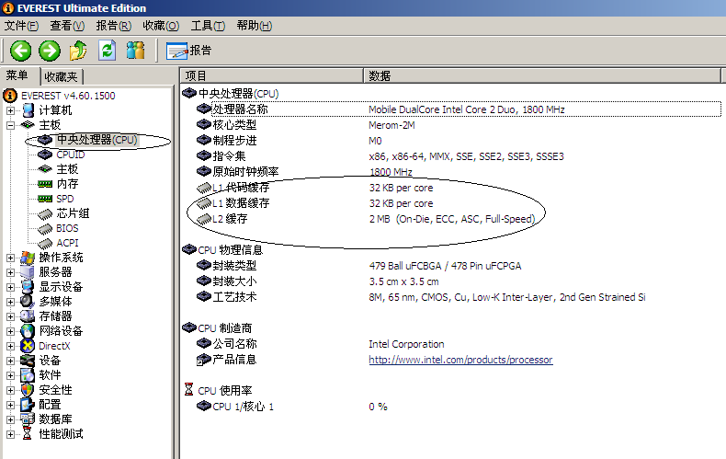

Now, run everest.exe to find out the information of your computer system’s Cache, and fill the blank.
Type | Size in byte
L1 cache
L2 cache
L3 cache

The project of memory_mountain
Please download the project of memory_mountain.rar first.
This project if the Windows-version of CMU CSAPP of mountain.c, which you can find in
- the textbook chapter 6.6(Notes: this is the first version),
- or from http://csapp.cs.cmu.edu/public/1e/public/code.html/mountain.c(Notes: this is the first version)
- or from http://csapp.cs.cmu.edu/public/code.html/mountain.c(Notes: this is the first version)

Your Task
Note that： Generate out.txt by run the program in release version, not debug. You can rotate the graph to get a better viewport.
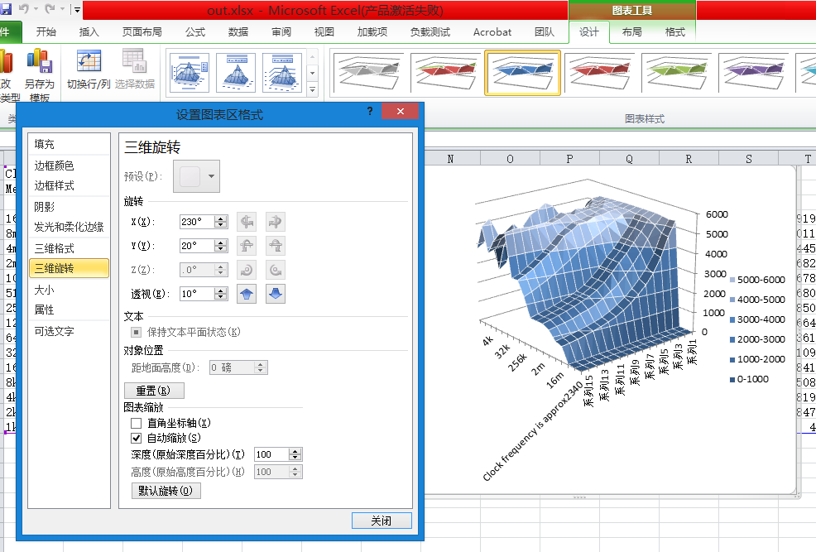
1．Read the source code in mountain.cpp, and answer the following questions: (Notes: you don’t have to pay too much attention on the function fcyc2() )
1) What is the variable of size and stride used for?

1) What is the meaning of the return value of the function run()?

2．If necessary, make some change to the value of MINBYTES, MAXBYTES, and MAXSTRIDE.
3．Build the project and run it, the you can get an output file named as out.txt.
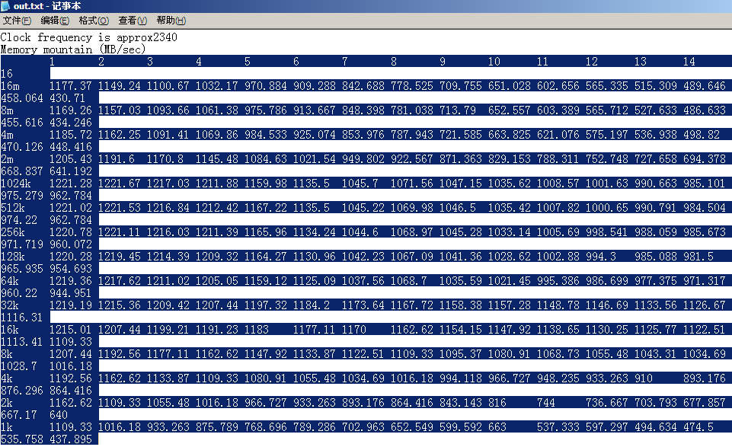
4．Copy the data in out.txt into an Excel file. Just as shown in the following figure.
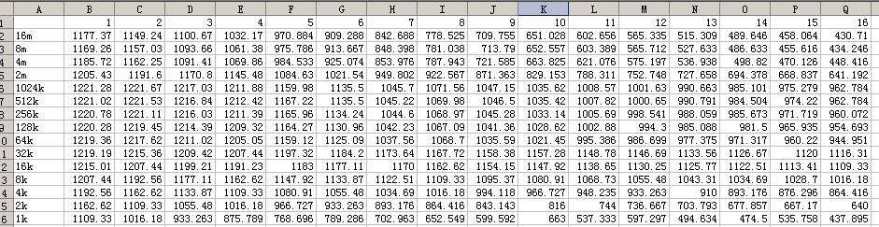
5．Click any cell in this Excel file, then add a chart.
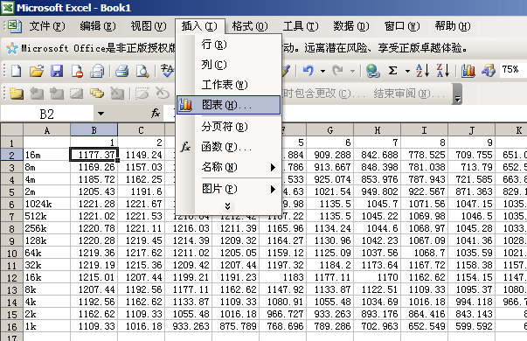

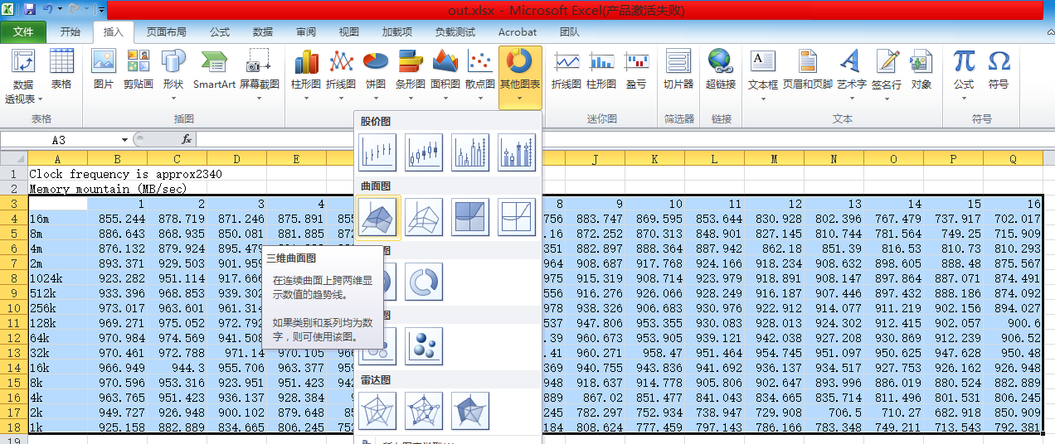

Then click Finish.

5．Then you can get a figure alike this:
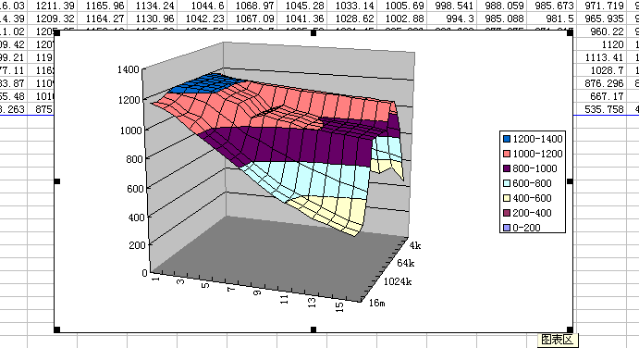

6. The following two figures are from CSAPP e1 and CSAPP e2
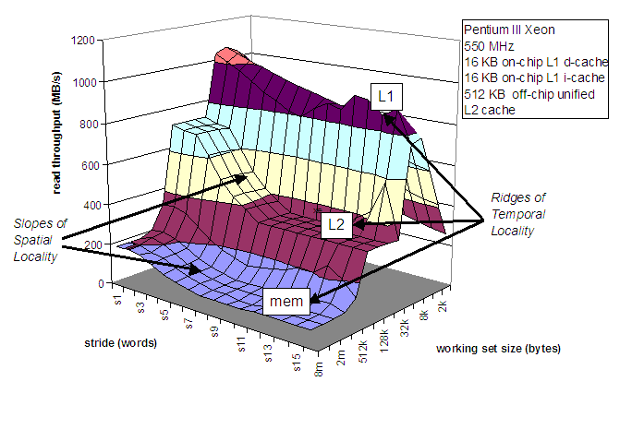
Figure of CSAPP e1

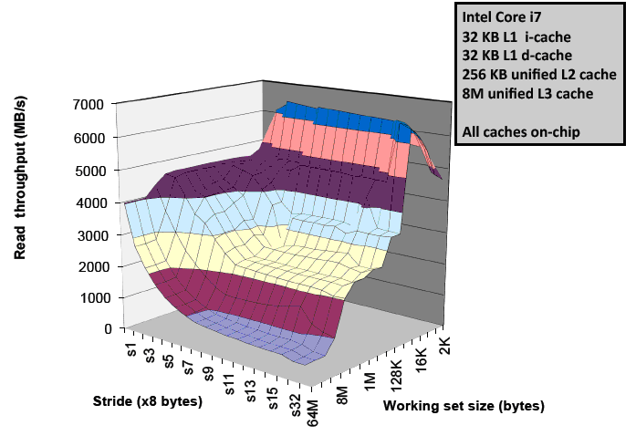
Figure of CSAPP e2

7．Just Paste your figure here:

8．How many ridges(山脊) do you get? And what are they correspond to?

9．Just compare the mountain with the information that you just got by running as everest.exe. And explain the How the spatial locality and temporal locality are shown in this figure.

